2011
Proxy Season Preview

Germany

Report Author
Thomas von Oehsen
thomas.vonoehsen@issgovernance.com

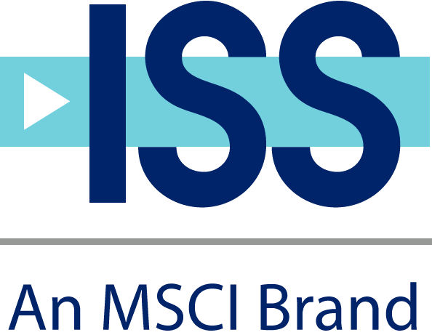

Key Takeaways
- In 2010, the first year of "say on pay" in Germany, there was a high response rate of blue chip companies to take advisory votes on management board remuneration, and market observers anticipate an increased number of "say on pay" resolutions at small and mid-sized listed companies in 2011.

- Many companies will monitor the structure and level of supervisory board remuneration this year to upgrade fixed remuneration and decrease or abolish variable pay components in spite of the recommendation of the German Corporate Governance Code that supervisory board members should receive fixed as well as performance-related remuneration.

- Supervisory boards will aim for more diversity and, in particular, female representation due to public pressure and recent amendments to the German Corporate Governance Code.

- While proxy season lasts three to four months, peak season is expected from the beginning of April until the end of May.

'Say on Pay'
In summer 2009, the German Act on the Appropriateness of Management Board Remuneration (Gesetz zur Angemessenheit der Vorstandsvergütung) came into effect, introducing changes to remuneration practices in Germany. The goal was to strengthen the link between pay and performance at publicly listed companies in Germany. Under the new law, "say on pay" was introduced for the first time in Germany and shareholders of listed companies were able to pass non-binding resolutions on the system of management board remuneration as set forth in Article 120 para. 4 of the German Stock Corporation Act (Aktiengesetz).
The law further sought to incentivize sustainable financial results and give directors the authority to reduce executive pay. The legislation is intended to make executive remuneration more transparent and geared to a company’s long-term interests. The act generally stipulates that remuneration should be in line with industry and market standards.
While it was uncertain how many companies would agree to hold such "say on pay" votes, it had been expected that a large majority of Germany’s blue chip DAX-30 companies would hold votes on their remuneration practices during the 2010 proxy season. In the end, 27 out of 30 DAX-companies gave shareholders the opportunity to vote on management board's remuneration systems.
Several companies have already indicated that they will add such a voluntary "say on pay" proposal to their 2011 AGM agendas again. Although German companies' pay systems are still on the move, the implementation of the voluntary advisory vote has become an achievement in business practice that the vast majority of DAX and MDAX companies consider useful.
In 21 of the 27 cases, shareholders approved the companies' remuneration system with 93 percent or more. Three remuneration systems were approved by less than 90 percent but still more than 86 percent. In two cases (Deutsche Bank and Deutsche Börse), a significant minority of shareholders opposed the presented pay systems while the system of HeidelbergCement was rejected.
Although, an acceptance level of 90 percent of the companies in Germany's blue chip index appears predominantly positive, it has to be noted, however, that the willingness for such "say on pay" votes was less pronounced in other DAX indices where the acceptance rates at smaller companies decreased dramatically due to a probable perception of legal uncertainties last year. While 63 percent of the companies in the MDAX (the 50 Prime Standard shares from sectors excluding technology that rank immediately below the companies included in the DAX-30 index) held resolutions on executive remuneration, only 44 percent in the TecDAX (the 30 largest German companies from the technology sector) and only 27 percent in the SDAX (50 smaller companies, that rank directly below the MDAX) allowed shareholders to vote on management board's remuneration.
Acceptance of "Say on Pay" at German DAX-30 Companies in Proxy Season 2010:
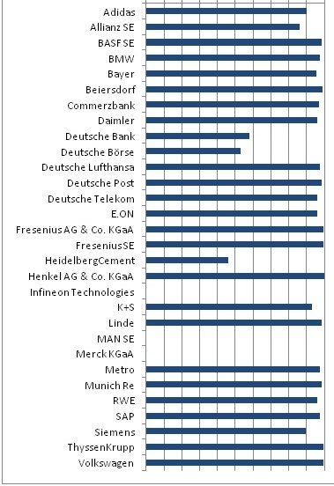 10% 30% 50% 70% 90%
For proxy season 2011, market observers anticipate a comparable response rate to "say on pay" in all DAX indices combined. Due to the lower response rate of smaller companies in 2010, it is expected that more small and mid-size companies will put "say on pay" on their meeting agendas this year. While the terms of the Act on the Appropriateness of Management Board Remuneration do not require annual "say on pay," some companies may seek shareholder approval again when setting executive remuneration policies. However, most companies that have included "say on pay" on their agendas this year either did not consider it in 2010 or made modifications to their existing pay systems, which was the case at ThyssenKrupp and Siemens. These companies were the first from the DAX-30 to again have "say on pay" on their meeting agendas in January 2011. Shareholders accepted the modified remuneration systems with more than 94 percent of the votes in both cases.
One and a half years after the introduction of the German Act on the Appropriateness of Management Board Remuneration, first experiences do not show a significant salary increase but a shift from short-term incentives toward an appreciation of the fixed remuneration as well as variable long-term pay, which is line with the objectives of the Act.

Supervisory Board Remuneration
The German Stock Corporations Act (Aktiengesetz) does not dictate supervisory board remuneration as board memberships were perceived as "secondary" or "honorary" employments at the time the act became effective in 1966. In today's practice, however, board members receive remuneration for their work as regulated in Article 113 para. 1 of the Aktiengesetz.
In Germany, compensation of the members of the supervisory board is usually specified in full detail in the articles of association. Only some companies determine supervisory board remuneration by a simple decision of the general meeting, which is valid until a subsequent vote is taken. Even fewer companies call for an annual decision by the general meeting on supervisory board remuneration.
The Aktiengesetz stipulates that the remuneration system has to take into account the responsibilities and scope of tasks of the members of the supervisory board as well as the economic situation and performance of the enterprise. Item 5.4.6 of the German Corporate Governance Code (Kodex) recommends that the exercising of the chair and deputy chair positions in the supervisory board as well as the chair and membership in committees should be considered in the remuneration system as well.
The Kodex also suggests that members of the supervisory board receive fixed as well as performance-related compensation and that performance-related compensation should include elements that are based on the long-term performance of the enterprise as well as short-term success.
Proponents of the Kodex recommendation usually bring forward the argument that compensation schemes that include variable remuneration components provide for a direct link between pay and performance and incentivize directors in their supervision of the management board. In spite of this recommendation, however, variable remuneration for supervisory board members more and more has come under criticism in Germany.
Opponents of the Kodex recommendation argue that the main duty of a supervisory board is to control the management board and, if necessary, to take corrective actions in the best interest of the company. The controlling function of the supervisory board could be undermined if economic success would financially incentivize board members to approve high-risk businesses in order to realize profits and to increase their variable remuneration. Consequently, it is argued, supervisory board members should not participate in short-term company success. Board members should make their decisions independently from any personal and financial interests, especially in times when intensive actions are particularly required for the sake of the company. Dispensing with a performance-related remuneration of the supervisory board members could help board members to work more independently without any distracting influences and to provide for a more effective supervision of the management board.
At its 2011 AGM in January, Siemens AG proposed changes to the remuneration schedule for members of its supervisory board, which no longer comprises any variable elements, making Siemens the fourth company in Germany's DAX-30 index after Daimler, Fresenius Medical Care, and Adidas with fixed remuneration only. In addition, companies such as Deutsche Lufthansa, Deutsche Post, HeidelbergCement, and SAP have at least upgraded fixed remuneration components in the recent past, while others revalued long-term variables at the expense of short-term components and/or increased committee work and attendance fees.
These developments have influenced several members of the German Corporate Governance Code Commission, and now there is speculation that the current recommendation that demands fixed as well as performance-related board pay could be amended in such a way that companies with fixed supervisory board remuneration only would no longer need to declare non-compliance with the Kodex due to applied principles that are accepted as best practice in most other international jurisdictions.
Nevertheless, most DAX-30 companies have still adopted fixed and variable supervisory board remuneration components. All 30 companies (100 percent) pay their board members a fixed salary, with 77 percent also having a short-term component and 40 percent having a long-term component. Moreover, all but one company pays for extra committee work (97 percent) and 63 percent pay fees for attending board meetings. This demonstrates that variable components are still pretty considerable at German supervisory boards although it is expected that variable components will more and more disappear in future years.
In the course of the current discussion regarding the need of an increased professionalism on German supervisory boards, many companies are modifying their supervisory board remuneration systems in terms of the structure and level of remuneration. German companies are aware that adequate board pay can be a decisive advantage in attracting highly qualified and dedicated candidates for the increasingly important supervisory board work.

Diversity and Women

On the Board
Diversity and the representation of women on the board are currently under intense discussion in Germany and were the most notable issues that the German Corporate Governance Commission addressed at its last plenary meeting in summer 2010. According to a recent study by the German Institute for Economic Research (Deutsches Institut für Wirtschaftsforschung) that investigated Germany's biggest 200 corporations, only 3.2 percent of all management board members (and only 2.2 percent at DAX-30 companies – or four out of 186) and 10.2 percent of all supervisory board members are women. With respect to supervisory boards, it also has to be noted that approximately 70 percent of these women are employees and only 30 percent are shareholder representatives. The amended Kodex recommends that management boards and supervisory boards of listed companies should aim for more diversity and, in particular, "for an appropriate consideration of women."
Furthermore, companies should take into account their international operations when proposing members for their supervisory board, thus leading to a greater degree of international representation on the board, depending on their respective situations.
While the introduction of a legal quota for female board representation is not foreseen in the near future in Germany, companies nevertheless are under public pressure to improve board diversity and female representation. In order to make concrete plans more visible and transparent the Kodex also recommends that companies report on concrete objectives of the supervisory board and the status of the implementation in the Corporate Governance Report.

2011 Proxy Season

And Meeting Dates
Proxy season in Germany starts at the end of March and lasts until the beginning of July. Peak season is expected from the beginning of April until the end of May. On average, companies publish official meeting invitations in the eBundesanzeiger around six weeks prior to the meeting date.

This report is provided by Institutional Shareholder Services Inc. ("ISS"), an indirect wholly owned subsidiary of MSCI Inc. ("MSCI"). MSCI is a publicly traded company on the NYSE (Ticker: MSCI). As such, MSCI is not generally aware of whom its stockholders are at any given point in time. ISS has, however, established policies and procedures to restrict the involvement of any of MSCI's non-employee stockholders, their affiliates and board members in the content of ISS' reports. Neither MSCI's non-employee stockholders, their affiliates, nor MSCI's non-management board members are informed of the contents of any of ISS reports prior to their publication or dissemination. ISS makes its proxy voting policy formation process and summary proxy voting policies readily available to issuers, investors, and others on its public Web site (www.issgovernance.com/policy).
Issuers mentioned in this document may have purchased self-assessment tools and publications from ISS Corporate Services, Inc. (“ICS”), a wholly owned subsidiary of ISS, or ICS may have provided advisory or analytical services to the issuer. No employee of ICS played a role in the preparation of this document. Any issuer that is mentioned in this document may be a client of ISS, ICS, MSCI Inc., ISS’ parent company, or a subsidiary of MSCI Inc., or may be the parent of, or affiliated with, a client of ISS, ICS, MSCI Inc., or another MSCI Inc. subsidiary. If you are an ISS institutional client, you may inquire about any issuer's use of products and services from ICS by emailing disclosure@msci.com.
This document and all of the information contained in it, including without limitation all text, data, graphs, charts (collectively, the “Information”) are the property of ISS, its subsidiaries, or in some cases third-party suppliers. The Information may not be reproduced or disseminated in whole or in part without prior written permission of ISS.
The Information has not been submitted to, nor received approval from, the United States Securities and Exchange Commission or any other regulatory body. None of the Information constitutes an offer to sell (or a solicitation of an offer to buy), or a promotion or recommendation of, any security, financial product, or other investment vehicle or any trading strategy, and ISS does not endorse, approve, or otherwise express any opinion regarding any issuer, securities, financial products, or instruments or trading strategies.
The user of the Information assumes the entire risk of any use it may make or permit to be made of the Information.
ISS MAKES NO EXPRESS OR IMPLIED WARRANTIES OR REPRESENTATIONS WITH RESPECT TO THE INFORMATION AND EXPRESSLY DISCLAIMS ALL IMPLIED WARRANTIES (INCLUDING, WITHOUT LIMITATION, ANY IMPLIED WARRANTIES OF ORIGINALITY, ACCURACY, TIMELINESS, NON-INFRINGEMENT, COMPLETENESS, MERCHANTABILITY AND FITNESS FOR A PARTICULAR PURPOSE) WITH RESPECT TO ANY OF THE INFORMATION.
Without limiting any of the foregoing and to the maximum extent permitted by law, in no event shall ISS have any liability regarding any of the Information for any direct, indirect, special, punitive, consequential (including lost profits), or any other damages even if notified of the possibility of such damages. The foregoing shall not exclude or limit any liability that may not by applicable law be excluded or limited.

